**MEFA**

**UNIT-1**

Managerial economics, as the name itself implies, is an offshoot of two distinct disciplines: Economics and Management.

**Introduction to Economics**

Economics is the study of human activity both at an individual and national level. The economists of early age treated economics merely as the science of wealth. The reason for this is clear. Every one of us is involved in efforts aimed at earning money and spending this money to satisfy our wants such as food, Clothing, shelter, and others. Such activities of earning and spending money are called “Economic activities”.

It was only during the eighteenth century that Adam Smith, the Father of Economics, defined economics as the study of nature and uses of national wealth’.

Dr. Alfred Marshall, one of the greatest economists of the nineteenth century, writes “Economics is a study of man’s actions in the ordinary business of life: it enquires how he gets his income and how he uses it”. Thus, it is one side, a study of wealth; and on the other, and more important side; it is the study of man.

**Types of Economics:**

**1. Microeconomics**

The study of an individual consumer or a firm is called microeconomics (also called the *Theory of Firm*). Microeconomics deals with the behavior and problems of a single individual in an organization.

**2. Macroeconomics**

The study of ‘aggregate’ or total level of economic activity in a country is called *macroeconomics*. It studies the flow of economic resources or factors of production (such as land, labour, capital, organization and technology) It deals with total aggregates, for instance, total national income total employment, output, and total investment.

**Introduction to Management**

Management is the science and art of getting things done through people in formally organized groups. It is necessary that every organization be well managed to enable it to achieve its desired goals. Management includes a number of functions: *Planning, organizing, staffing, directing, and controlling*. The manager while directing the efforts of his staff *communicates* to them the goals, objectives, policies, and procedures; *coordinates* their efforts; *motivates* them to sustain their enthusiasm; and *leads* them to achieve the corporate goals.

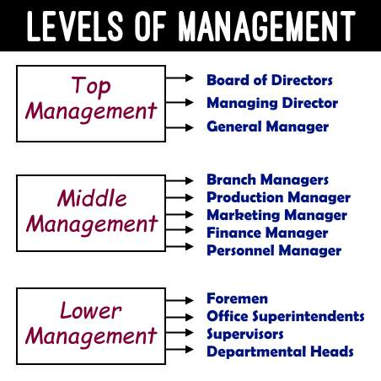

**Managerial Economics**

**Meaning & Definition**:

M. H. Spencer Defined “Managerial Economics is the integration of economic theory with business practice for the purpose of facilitating decision making and forward planning by management”.

In the words of E. F. Brigham and J. L. Pappas Managerial Economics is “the applications of economic theory and methodology to business administration practice”.

**Q1) Nature and significance of Managerial Economics**

1. ***Close to microeconomics***: Managerial economics is concerned with finding the solutions for different managerial problems of a particular firm. Thus, it is closer to microeconomics.
2. ***Operates against the backdrop of macroeconomics***: The macroeconomic conditions of the economy are also seen as limiting factors for the firm to operate. In other words, the managerial economist has to be aware of the limits set by the macroeconomic conditions such as government industrial policy, inflation and so on.
3. ***Normative statements***: A normative statement usually includes or implies the words ‘ought’ or ‘should’. They reflect people’s moral attitudes and are expressions of what a team of people ought to do. For instance, it deals with statements such as ‘Government of India should open up the economy. Such statements are based on value judgments and express views of what is ‘good’ or ‘bad’, ‘right’ or ‘ wrong’.
4. ***Prescriptive actions***: Prescriptive action is goal oriented. Given a problem and the objectives of the firm, it suggests the course of action from the available alternatives for optimal solution. If does not merely mention the concept, it also explains whether the concept can be applied in a given context on not. For instance, the fact that variable costs are marginal costs can be used to judge the feasibility of an export order.
5. ***Applied in nature***: ‘Models’ are built to reflect the real-life complex business situations and these models are of immense help to managers for decision-making. The different areas where models are extensively used include inventory control, optimization, project management etc. In managerial economics, we also employ case study methods to conceptualize the problem, identify an alternative and determine the best course of action.
6. ***ME relating with other subjects***: The contents, tools and techniques of managerial economics are drawn from different subjects such as economics, management, mathematics, statistics, accountancy, psychology, organizational behavior, sociology and etc.

**Functions of Managerial Economics or managerial decision areas:**

**1. Capital Decision:** capital refers to it is the initial amount of the organization. Capital refers to the financial assets, measured in terms of money, used by enterprises to produce their finished products or to render services to the economy. These include the funds deposited in the accounts or various funds obtained from various financial sources. Capital is a key component in the success of the business and on the macro level, for the growth of the economy. The capital can be generated internally in the form of retained earnings or it can be procured from external sources.

**2. Purchasing decision: it** is also known as the make-or-buy decision, which is an act of choosing between manufacturing a product in-house or purchasing it from an external supplier. Make-or-buy decisions, like outsourcing decisions, speak to a comparison of the costs and advantages of producing in-house versus buying it elsewhere.

**3. Demand Forecasting decision:** Demand forecasting refers to the estimation of the future demand for a particular product for a given period of time. A firm can survive only if it is able to the demand for its product at the right time, within the right quantity. Understanding the basic concepts of demand is essential for demand forecasting. Demand analysis should be a basic activity of the firm because many of the other activities of the firm depend upon the outcome of the demand forecast.

**4. Production decision:** Production analysis is in physical terms. It refers to the conversion of inputs into the output. Production decisions In decisions on producing or providing products and services in the market, it is essential that the production of the product or service is well planned and coordinated, both within and with another functional area of the firm, particularly marketing.

**5. Pricing decision:** Total value and worth of goods and services is known as the Price. Pricing is a process of fixation of price. Pricing decisions have been always within the preview of managerial economics. Price theory helps to explain how prices are determined under different types of market conditions. Competitions analysis includes the anticipation of the response of competition the firm’s pricing, advertising, and marketing strategies.

**6. Profit decision:** Profit-making is the major goal of firms. There are several constraints here an account of competition from other products, changing input prices and changing business environment hence in spite of careful planning, there is always a certain risk involved. Managerial economics deals with techniques of averting of minimizing risks.

**7. Investment Decision:** After receiving the profit management looks for various investment avenues to get double the benefit. Such as where to invest, when to invest how much amount needs to spend in a particular area. Such as real estate, bank savings, gold purchasing, and savings in shares and expand the current business operations.

**8. Cost reduction decision:** Cost refers to how much amount is required to make a particular product or service. While the cost analysis is in monetary terms cost concepts and classifications, cost-out-put relationships, economies and diseconomies of scale and production functions are some of the points constituting cost reduction analysis.

**Significance of managerial economics**

* **Better decision making**

Managerial economics helps managers make rational decisions that consider the implications of their choices.

* **Improved resource utilization**

Managerial economics helps ensure that resources are used efficiently, which can reduce costs.

* **Better profit planning**

Managerial economics helps managers estimate costs and revenues to plan and manage profits.

* **Better inventory management**

Managerial economics helps managers analyze demand and ensure they have the right amount of inventory.

* **Better business predictions**

Managerial economics helps managers predict future uncertainties so they can take steps to avoid them.

* **Better strategic planning**

Managerial economics helps managers develop strategies to achieve long-term goals.

* **Better environmental practices**

Managerial economics helps managers assess the impact of their business operations on the environment.

**2.Demand Analysis**

**Introduction & Meaning:**

Demand in common parlance means the desire for an object. But in economics demand is something more than this. According to Stonier and Hague, “Demand in economics means demand backed up by enough money to pay for the goods demanded”. This means that the demand becomes effective only it if is backed by purchasing power in addition to this there must be a willingness to buy a commodity.

Thus demand in economics means the desire backed by the willingness to buy a commodity and the purchasing power to pay. In the words of “Benham” “The demand for anything at a given price is the amount of it which will be bought per unit of time at that Price”.

**Factors determinants of demand or Factors Affecting on Demand:**

There are factors on which the demand for a commodity depends. These factors are economic, social as well as political factors. The effect of all the factors on the amount demanded for the commodity is called Demand Function.

These factors are as follows:

1. **Price of the Commodity:**

The most important factor-affecting amount demanded is the price of the commodity. The amount of a commodity demanded at a particular price is more properly called price demand. The relation between price and demand is called the Law of Demand. It is not only the existing price but also the expected changes in price, which affect demand.

1. **Income of the Consumer:**

The second most important factor influencing demand is consumer income. In fact, we can establish a relationship between consumer income and the demand at different levels of income, price, and other things remaining the same. The demand for a normal commodity goes up when income rises and falls down when income falls. But in the case of Giffen goods, the relationship is the opposite.

1. **Prices of related goods**:

The demand for a commodity is also affected by the changes in the prices of the related goods also. Ie Substitutes which can replace each other in use; for example, tea and coffee are   
 substitutes. The change in the price of a substitute has an effect on a commodity’s demand   
 4.**Tastes of the Consumers:**

The amount demanded also depends on the consumer’s taste. Tastes include fashion, habit, customs, etc. A consumer’s taste is also affected by advertisements. If the taste for a commodity goes up, its amount demanded is more even at the same price. This is called the increase in demand. The opposite is called a decrease in demand.

1. **Wealth:**

The amount demanded of a commodity is also affected by the amount of wealth as well as its distribution. The wealthier are the people; the higher is the demand for normal commodities. If wealth is more equally distributed, the demand for necessaries and comforts is more. On the other hand, if some people are rich, while the majorities are poor, the demand for luxuries is generally higher.

1. **Population size:**

An increase in population increases the demand for necessities of life. The composition of the population also affects demand. The composition of the population means the proportion of young and old and children as well as the ratio of men to women. A change in the composition of the population has an effect on the nature of demand for different commodities.

**7. Government Policy:**

Government policy affects the demand for commodities through taxation. Taxing a commodity increases its price and the demand goes down. Similarly, financial help from the government increases the demand for a commodity while lowering its price.

**8. Expectations regarding the future Price :**

If consumers expect changes in the price of commodities in the future, they will change the demand at present even when the present price remains the same. Similarly, if consumers expect their incomes to rise in the near future they may increase the demand for a commodity just now.

**9. Climate and weather conditions:**

The climate of an area and the weather prevailing there has a decisive effect on consumer demand. In cold areas, woolen cloth is demanded. During hot summer days, ice is very much in demand. On a rainy day, ice cream is not in so much demand.

**Demand Function:**

A demand function is a mathematical equation that expresses the demand of a product or service as a function of its price and other factors such as the prices of the substitutes and complementary goods, income, etc.

A demand function creates a relationship between the demand (in quantities) of a product (which is a dependent variable) and factors that affect the demand such as the price of the product, the price of substitute and complementary goods, average income, etc., (which are the independent variables).

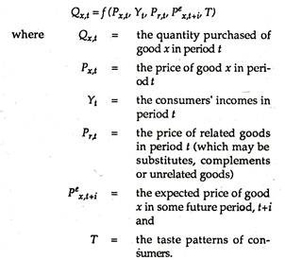

**LAW of Demand:**

The law of demand shows the relation between the price and quantity demanded of a commodity in the market. In the words of Marshall, “the amount of demand increases with a fall in price and diminishes with a rise in price”.

A rise in the price of a commodity is followed by a reduction in demand and a fall in price is followed by an increase in demand, if a condition of demand remains constant.

The law of demand may be explained with the help of the following demand schedule.

**Demand Schedule.**

|  |  |
| --- | --- |
| **Price of Appel (In. Rs.)** | **Quantity Demanded** |
| 10 | 1 |
| 8 | 2 |
| 6 | 3 |
| 4 | 4 |
| 2 | 5 |

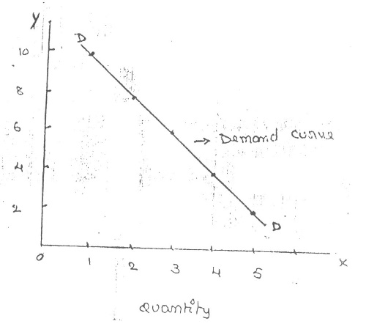When the price falls from Rs. 10 to 8 quantity demand increases from 1 to 2. In the same way, as price falls, quantity demand increases on the basis of the demand schedule we can draw the demand curve.

The demand curve DD shows the inverse relation between the price and quantity demand of apples. It is downward sloping.

**Limitations or Exceptional of law of demand curve:**

Sometimes the demand curve slopes upwards from left to right. In this case, the demand curve has a positive slope.

When the price increases from OP to Op1 quantity demanded also increases from OQ1 and vice versa. The reasons for the exceptional demand curve are as follows.

**1. Giffen paradox:**

The Giffen good or inferior good is an exception to the law of demand. When the price of an inferior good falls, the poor will buy less and vice versa. For example, when the price of maize falls, the poor are willing to spend more on superior goods than on maize if the price of maize increases, he has to increase the quantity of money spent on it. Otherwise, he will have to face starvation. Thus a fall in price is followed by a reduction in quantity demanded and vice versa. “Giffen” first explained this and therefore it is called as Giffen’s paradox.

**2. Veblen or Demonstration effect:**

‘Veblan’ has explained the exceptional demand curve through his doctrine of conspicuous consumption. Rich people buy certain goods because it gives social distinction or prestige for example diamonds are bought by the richer class for the prestige they possess. If the price of diamonds falls poor also will buy it hence they will not give prestige. Therefore, rich people may stop buying this commodity.

**3. Ignorance:**

Sometimes, the quality of the commodity is judged by its price. Consumers think that the product is superior if the price is high. As such, they buy more at a higher price.

**4. Fear of shortage:**

During the times of emergency of war People may expect a shortage of a commodity. At that time, they may buy more at a higher price to keep stocks for the future.

**3.ELASTICITY OF DEMAND**

The elasticity of demand explains the relationship between a change in price and the consequent change in the amount of demand. “Marshall” introduced the concept of elasticity of demand.

In the words of “Marshall”, “The elasticity of demand in a market is great or small according as the amount demanded increases much or little for a given fall in the price and rise in Price”

**Types of Elasticity of Demand:**

There are Four types of elasticity of demand:

1.Price elasticity of demand

2.Income elasticity of demand

3.Cross elasticity of demand

4. Advertising Elasticity Demand

**1. Price elasticity of demand:**

Marshall was the first economist to define price elasticity of demand. Price elasticity of demand measures changes in quantity demand to a change in Price. It is the ratio of a percentage change in quantity demanded to a percentage change in price.

  Proportionate change in the quantity demand of the commodity

**Price elasticity** = ------------------------------------------------------------------ *100

Proportionate change in the price of a commodity

**2. Income elasticity of demand:**

Income elasticity of demand shows the change in quantity demanded as a result of a change in income. The income elasticity of demand may be slated in the form of a formula.

Proportionate change in the quantity demand of the commodity

**Income Elasticity** = ------------------------------------------------------------------ *100

Proportionate change in the income of the people

**3. Cross elasticity of Demand:**

A change in the price of one commodity leads to a change in the quantity demanded of another commodity. This is called a cross elasticity of demand.

Proportionate change in the quantity demand of commodity “**X”**

**Cross elasticity** = ----------------------------------------------------------------------- *100

Proportionate change in the price of commodity “**Y”**

1. **Advertising elasticity of demand (AED) :**

AED is a measure of a market's sensitivity to increases or decreases in advertising saturation. It is calculated by dividing the percentage change in the quantity demanded by the percentage change in advertising expenditures.

Proportionate change in the quantity demand of the commodity

**Advertising elasticity** = ------------------------------------------------------------------ *100

Proportionate change in the advertising expenditure

**Measurements of price elasticity of demand**

**A. Perfectly elastic demand**

When there is no changes in price it leads to an infinitely large change is quantity demand, it is called perfectly or infinitely elastic demand. In this case E=∞

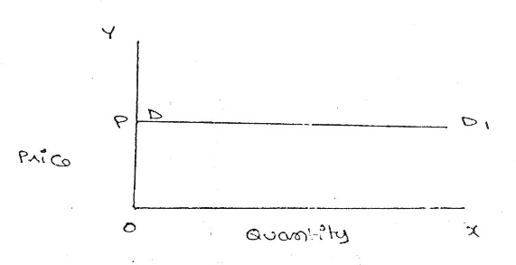

  The demand curve D to D1 is a horizontal straight line. It shows that at “OP” if the price increases, the consumer will not purchase the commodity. Example: Quality Products

**B. Perfectly Inelastic Demand**

There is no changes in the quantity of demand In this case, even a large change in price fails to bring about a change in the quantity demanded. E=0

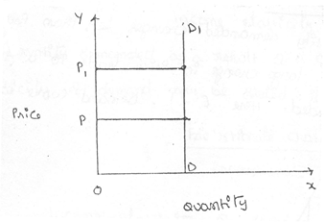

When the price increases from ‘OP’ to ‘OP1’, the quantity demanded remains the same. In other words, the response of demand to a change in Price is nil.Example: Cooking salt

**C. Relatively elastic demand**

The quantity of Demand changes more than proportionately to a change in price. But here a small change in price leads to a very big change in the quantity demanded. E > 1

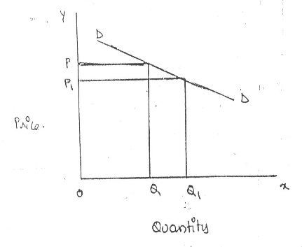

  When the price falls from ‘OP’ to ‘OP1’, the amount demanded increases from “OQ’ to “OQ1’ which is larger than the change in price. Example; Home applience

**D. Relatively in-elastic demand**

Quantity demand changes less than proportional to a change in price. A large change in price leads to small change in amount demanded. Here E < 1.

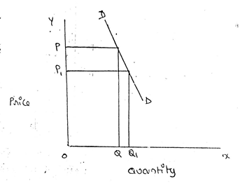

 When the price falls from “OP’ to ‘OP1 amount demanded increases from OQ to OQ1, which is smaller than the change in price. Example: luxury cars

**E. Unitary or equal elasticity of demand:**

The changes in demand are exactly equal to the change in price. When both are equal E=1 and elasticity if said to be unitary.

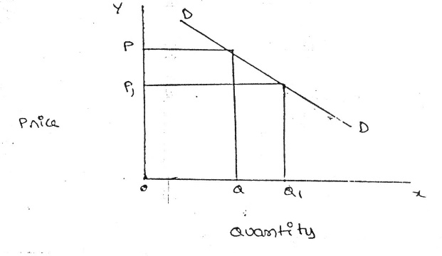

  When price falls from ‘OP’ to ‘OP1’ quantity demanded increases from ‘OQ’ to ‘OQ1’. Thus a change in price has resulted in an equal change in quantity demanded so price elasticity of demand is equal to unity.

**Importance of Elasticity of Demand:**

**1. Price fixation:**

 Each seller under monopoly and imperfect competition has to take into account elasticity of demand while fixing the price for his product. If the demand for the product is inelastic, he can fix a higher price.

**2. Production Planning:**

 Producers generally decide their production level on the basis of demand for the product. Hence elasticity of demand helps the producers to take correct decisions regarding the level of cut to be produced.

**3. Public Finance:**

 The elasticity of demand helps the government in formulating tax policies. For example, for imposing tax on a commodity, the Finance Minister has to take into account the elasticity of demand.

**DEMAND FORECASTING**

**Demand Forecasting** is a systematic and scientific estimation of future demand for a product. Simply, estimating the sales proceeds or demand a product in the future is called demand forecasting.

It is an ‘objective assessment of the future course of demand”. In recent times, forecasting plays an important role in business decision-making. Demand forecasting has an important influence on production planning. It is essential for a firm to produce the required quantities at the right time.

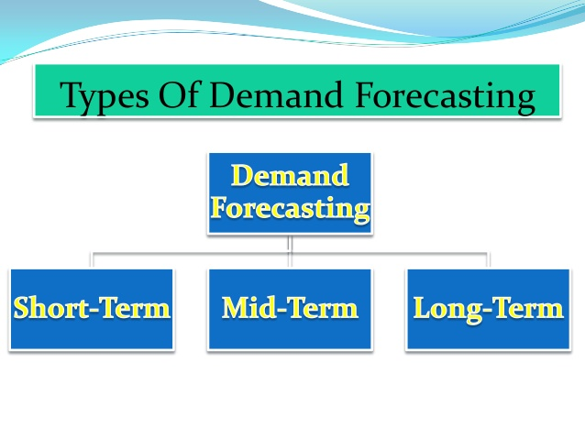

**Factors Affecting on Demand Forecasting:**

**Price of Goods**: Demand estimation is highly dependent on the price of goods or services. The pricing policy and fluctuation in the present price can give an idea of the change in demand for that particular commodity.

**Type of Goods**: The kind of commodity, its features and usability determine the customer base it is going to cater. The demand for existing goods can be easily estimated by following the previous sales trend, competitors’ analysis, and substitutes available. Whereas, the demand for a new product on the market is difficult to predict.

**Competition**: The level of competition in the market supports the process of demand forecasting. It is easy to predict sales in a less competitive market, whereas the same becomes difficult in a market where the new firms can freely enter.

**Technology**: The demand for any product or service changes drastically with the advancement in technology. Therefore, it is essential for an organization to be aware of technological development while forecasting the demand for any commodity.

**Various Methods of Demand forecasting:**

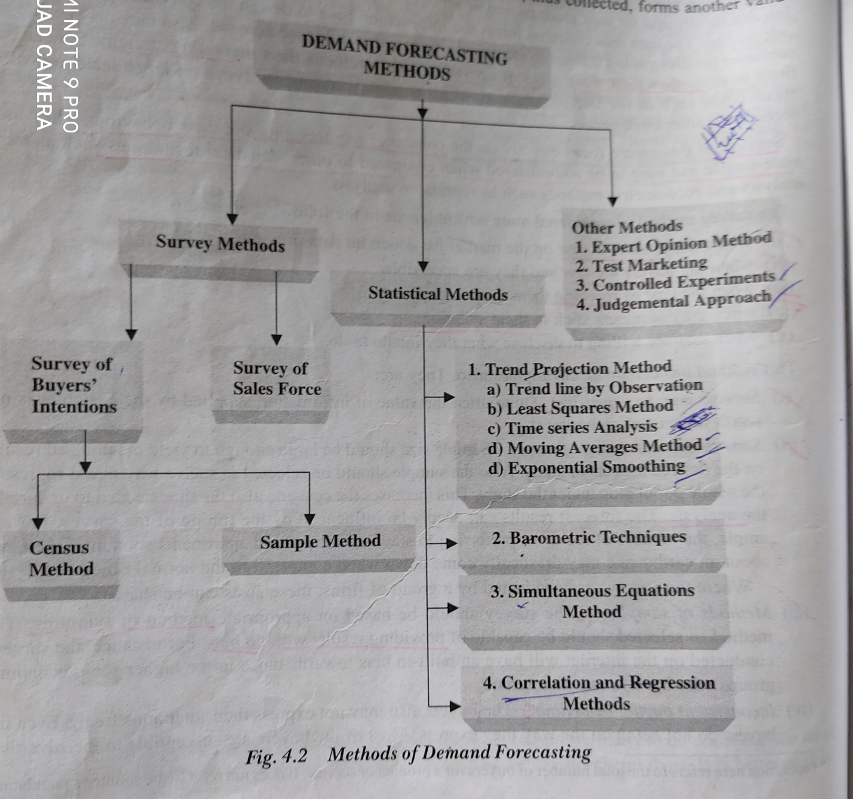

Several methods are employed for forecasting demand. All these methods can be grouped under the survey method and statistical method. Survey methods and statistical methods are further subdivided into different categories.

**1. Survey Method:**

Under this method, information about the desires of the consumer and opinion of exports are collected by interviewing them. Survey method can be divided into two types.

1.Buyers survey

2.Sellers survey.

**A. Buyers survey method:** It is also known as the consumers' expectations or opinions survey. A sample of potential consumers is surveyed to know how much of the stated product they would buy at a given price during a specified future time period.

**(I) Census method:** A statistical investigation in which the data are collected for each and every element/unit of the population, it is termed as Census Method. It is also known as 'Complete Enumeration' or '100% Enumeration or Complete survey.

(II) A **sampling method:** It is a procedure for selecting sample members from a population. To identify the future demand. This method mainly helping to reduce the cost and time consuming in data collection.

**B.sellers Survey method:**

This method is also known as the sales-force composite method (or) collective opinion method. Under this method, the company asks its salesman to submit an estimate of future sales in their respective territories. Since the forecasts of the salesmen are biased due to their optimistic or pessimistic attitude ignorance about economic developments etc. This method is more useful and appropriate because the salesmen are more knowledgeable. They can be an important source of information.

2. **Statistical Methods:**

The statistical method is used for long-run forecasting. In this method, statistical and mathematical techniques are used to forecast demand. This method relies on post-data.

**A..Trend line by observation method:** these are generally based on analysis of past sales patterns, these methods dispense with the need for costly market research because the necessary information is often already available in company files in terms of different time periods.

## B.Time series analysis: A time series is a sequence of numerical data points in successive order. In investing, a time series tracks the movement of the chosen data points, such as a security’s price, over a specified period of time with data points recorded at regular intervals. There is no minimum or maximum amount of time that must be included, allowing the data to be gathered in a way that provides the information being sought by the investor or analyst examining the activity.

## C.Moving average methods: this method is easy to compute it considers that the average of past events determines the future event.in other words, this method provides consistent results when the past is consistent ad unaffected by wide changes as the name itself suggests under this method the average keeps on moving to depend on the number of years selected.

## D. least square method: The**least square method** is the process of finding the best-fitting curve or line of best fit for a set of data points by reducing the sum of the squares of the offsets (residual part) of the points from the curve. During the process of finding the relation between two variables, the trends of outcomes are estimated quantitatively.

## E. Barometric Method: where forecasting based on time series analysis may not yield significant results, barometric techniques can be made use of it. Under the barometric technique, one set of data is used to predict another set. in other words to demand forecast for a particular product or service, use some other relevant indicator of future demand.

**F. Regression and correlation method:**

Correlation and regression methods are statistical techniques. Correlation describes the degree of association between two varibles used for forecasting demand. Based on post data the future data trend is forecasted. If the functional relationship is analyzed with the independent variable it is a simple correction. Such as sales and advertising expenditure, income and sales The main advantage of this method is that it provides the values of the independent variables from within the model itself.

**3.Others Methods:**

**A. Expert opinion method:**

Apart from salesmen and consumers, distributors or outside experts may also e used for forecasting. Firms in advanced countries make use of outside experts for estimating future demand. Various public and private agencies all periodic forecasts of short or long-term business conditions.

**B.Test marketing:** **Test marketing** is a tool used by companies to check the viability of their new product or a marketing campaign before it is launched in the market on a large scale.

The market test is generally carried out to ascertain the probable market success in terms of the new product’s performance, the level of acceptance of the product, customer satisfaction, and the efficiency of the marketing campaign.

**C.Own judge mental approach:** when none of the above methods are directly related to the given product or service the management has no alternative other than using its own judgment. even when the above methods are used the forecasting process is supplemented with the factor of judgment whereas past data is not available, sales fluctuations are wide and significant.